TALIPOT STUDIO presents

In association with PERCEVAL PICTURES

a TALIPOT STUDIO, RECORDED PICTURE COMPANY PERCEVAL PICTURES production

IN ASSOCIATION WITH

HANWAY FILMS



Written and Directed by VIGGO MORTENSEN

Produced by

REGINA SOLORZANO  
JEREMY THOMAS

VIGGO MORTENSEN, p.g.a.

Executive Producers

ROBERTO PAXSON, GABRIEL TERRAZAS

Executive Producers

IVAN KELAVA, DANIEL BEKERMAN, JESPER MORTHORST

Executive Producers

PAULA ASTORGA RIESTRA, PETER WATSON

Co Producers

GIA GALLIGANI, ANGELA BLAIR

STARRING

VICKY KRIEPS, VIGGO MORTENSEN, SOLLY McLEOD, GARRETT DILLAHUNT, COLIN MORGAN, RAY MCKINNON, W. EARL BROWN, ATLAS GREEN, DANNY HOUSTON

Line Producer

MARIANA RODRIGUEZ CABARGA

Director of Photography

MARCEL ZYSKIND, DFF

Production Design

CAROL SPIER, JASON CLARKE

Editor

PEDER PEDERSEN

Costume Designer

ANNE DIXON

Hair and Make-Up Designer

ATENEA TELLEZ

Casting

JEANNE McCARTHY, CSA, NATHALIE BOUTRIE, ADCQ

Casting Consultant

DEIDRE BOWEN, CDC

Sound Designer

MORTEN GROTH BRANDT

Sound Mixer

GABRIEL COLL BARBERIS

Composer

VIGGO MORTENSEN

RUNNING TIME: 129 minute

——-

PRESS CONTACTS:

Ryan Werner / ryan@cineticmedia.com - Courtney Ott / [courtney@cineticmedia.com](mailto:courtney@cineticmedia.com)

*The Dead Don’t Hurt* is a story of star-crossed lovers that takes place on the western U.S. frontier in the 1860s. Vivienne Le Coudy (Vicky Krieps) is a fiercely independent woman who embarks on a relationship with Danish immigrant Holger Olsen (Viggo Mortensen). After meeting Olsen in San Francisco, she agrees to travel with him to his home near the quiet town of Elk Flats, Nevada, where they start a life together. The outbreak of the Civil War separates them when Olsen makes a fateful decision to fight for the Union. This leaves Vivienne to fend for herself in a place controlled by corrupt Mayor Rudolph Schiller (Danny Huston) and his unscrupulous business partner, powerful rancher Alfred Jeffries (Garret Dillahunt). Alfred's violent, wayward son Weston (Solly McLeod) aggressively pursues Vivienne, who is determined to resist his unwanted advances. When Olsen returns from the war, he and Vivienne must confront and make peace with the person each has become. Both a tragic love story and a nuanced depiction of the conflict between revenge and forgiveness, *The Dead Don’t Hurt* is a portrait of a passionate woman determined to stand up for herself in an unforgiving world dominated by ruthless men.

*The Dead Don’t Hurt* marks Mortensen’s second outing as writer-director after his highly acclaimed feature debut, 2020’s *Falling*. The film reunites Mortensen with key members of *Falling*’s creative team: cinematographer Marcel Zyskind (*As in Heaven*), production designers Carol Spier (*Eastern Promises*) and Jason Clarke (*Black Mirror*), and costume designer Anne Dixon (*The Song of Names*).

Produced by Regina Solórzano, Jeremy Thomas and Mortensen, *The Dead Don’t Hurt* will make its world premiere as a special presentation at the Toronto International Film Festival.

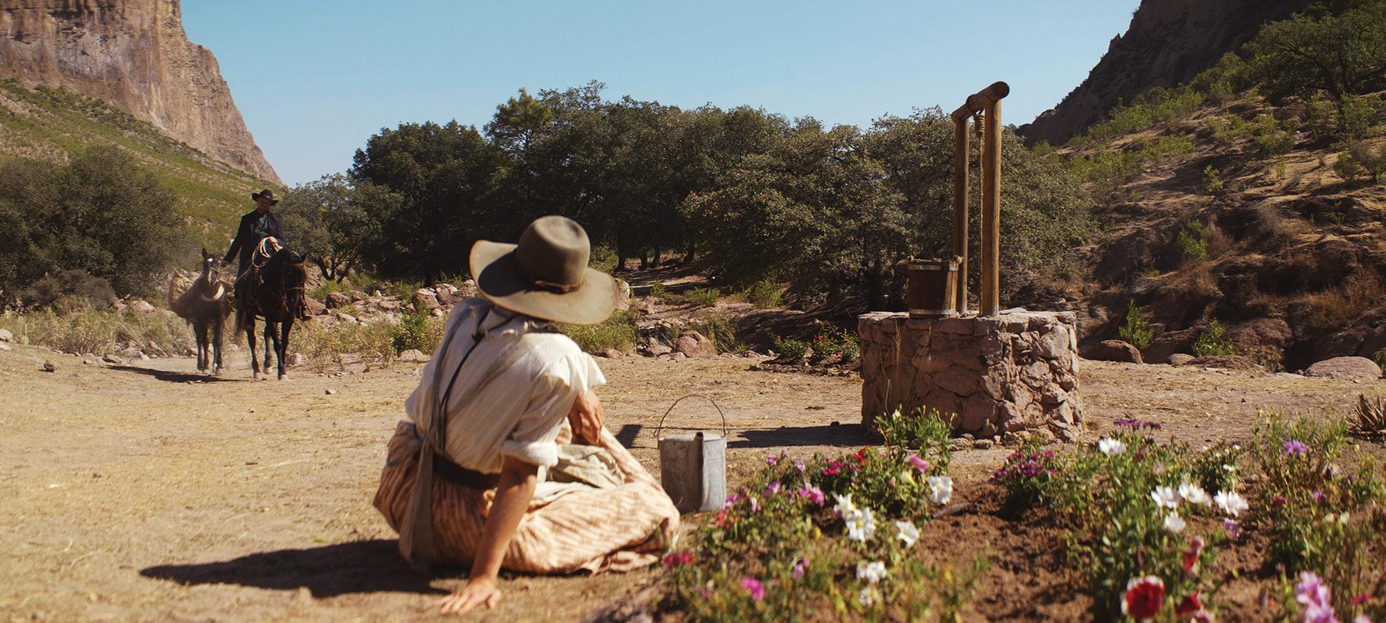

**ON THE ORIGINS, PRODUCTION, AND THEMES OF *THE DEAD DON’T HURT***

With his 2020 feature screenplay and directorial debut *Falling*, Academy Award®-nominated actor Viggo Mortensen channeled some of his feelings about his late mother’s passing into a compelling family drama about the complexities of parent-child relationships—and the ways in which those bonds can become strained by the re-opening of old psychological wounds, while offering opportunities for hard-won healing. With *The Dead Don’t Hurt*, his second outing as writer-director, he was again inspired by his mother—although this time developing a very different kind of film in the *western*genre.

“This was a story that arose from an image of my mother,” Mortensen says. “I have illustrated books from the 1930s that she used to read when she was a little girl, stories about knights, medieval adventure stories. She had been raised near maple forests in the northeast of the U.S., near the Canadian border, and I had the image of her as a child running around in those forests, imagining she was in one of the stories she had read in those old books. That was the initial image I had as I sat down to begin writing the screenplay for *The Dead Don’t Hurt* during the COVID lockdown in the Spring of 2020.”

At that point, Mortensen asked himself what might have happened to the woman that the little girl becomes, and he admits that he was somewhat surprised by the path the story took. “I thought, *Well, let’s begin the story when the girl has become a woman at the end of her life*,” he says. “I’m not sure why, but I decided to make a journey as a writer to learn how that care-free little girl got there.”

The film’s central character is French-Canadian immigrant Vivienne Le Coudy (Vicky Krieps), a free-spirited woman who makes a living selling flowers in San Francisco. She impulsively chooses a new life-path when she meets Danish immigrant Holger Olsen (Viggo Mortensen), a man as uncompromisingly self-reliant as she is. Falling in love, they pursue an initially tranquil life together in Elk Flats, Nevada, the frontier community that Olsen calls home.

“What happens in this story is that Holger meets a woman, Vivienne, who is somewhat like him— a thoroughly independent woman, as stubborn as he is, very much her own person,” explains Mortensen. “She’s someone who is able to live alone and solve her own problems. An attraction arises, perhaps unexpectedly, between these two people, and they decide to embark on a journey together, to join their lives and see where that takes them.”

Together, they create a kind of rural idyll for themselves, with Vivienne’s innate restlessness and drive gently pushing Olsen to become a more active sort. “He is a man who has travelled a great deal, but he likes life in the North American West and has put down roots,” says Mortensen. “He has adapted to the point that you could almost say he is a Scandinavian cowboy. Solitary by nature, he is a respectable carpenter and a writer – as well as a former soldier - but might seem a bit lazy because he tends to do only what he likes and doesn’t worry too much about money.”

Their happy routine is interrupted by Olsen’s decision to volunteer to fight for the Union shortly after the outbreak of the Civil War. Left on her own, Vivienne is faced with confronting the ruthless men who govern the town, including the violent Weston Jeffries, who forces his unwanted attentions on her. A violent incident changes the course of her life forever, leaving her relationship with Holger in a kind of emotional limbo once he returns home and makes a surprising discovery. Their bond is put to the test, and they must find a way to move forward together if their relationship is to survive.

With its wide-open vistas and 19th century setting, *The Dead Don’t Hurt* has the look of a classic *western*, but for Mortensen, this story defies easy categorisation. “It is a very particular sort of *western*,” he says. “*The Dead Don’t Hurt* seemed to me to have the potential to become an unusual love story within the context of that genre, which I have always been fond of, but it clearly breaks with some of the conventional archetypes that have been used to depict female roles in that kind of movie.”

Producer Regina Solórzano (*Triangle of Sadness*, *Bergman Island*) found herself moved by Mortensen’s quietly revolutionary screenplay and especially its relatable, resilient female protagonist. Partnering with Mortensen and renowned independent film producer Jeremy Thomas, Solórzano was eager to bring *The Dead Don’t Hurt* to the screen through Mexican production company, Talipot Studio where she is currently CEO.

*“*It is a story that falls within the genre of classic *westerns*, but this movie can be viewed on many different levels,” says Solórzano. “It employs that surface appearance of a *western*

to speak of a revolutionised world, of a woman who, to me, seems to be quite ahead of her time, with a different perspective of what femininity is, what the role of a woman is. She’s someone who is not in service of the existing social structures, and elects to be with a man who has the humility and capacity, despite his own patriarchal code, to respect that.”

To play Vivienne Le Coudy, the filmmakers turned to Luxembourg actress Vicky Krieps, whose acclaimed work in the 2017 Oscar®-winning drama *Phantom Thread* opposite Daniel Day-Lewis brought her international acclaim. Her recent starring performance as Empress Elizabeth of Austria in 2022’s *Corsage* cemented her reputation as a performer with a tremendous facility for portraying intelligent, complicated women wrestling with the limitations and expectations of a male-dominated society.

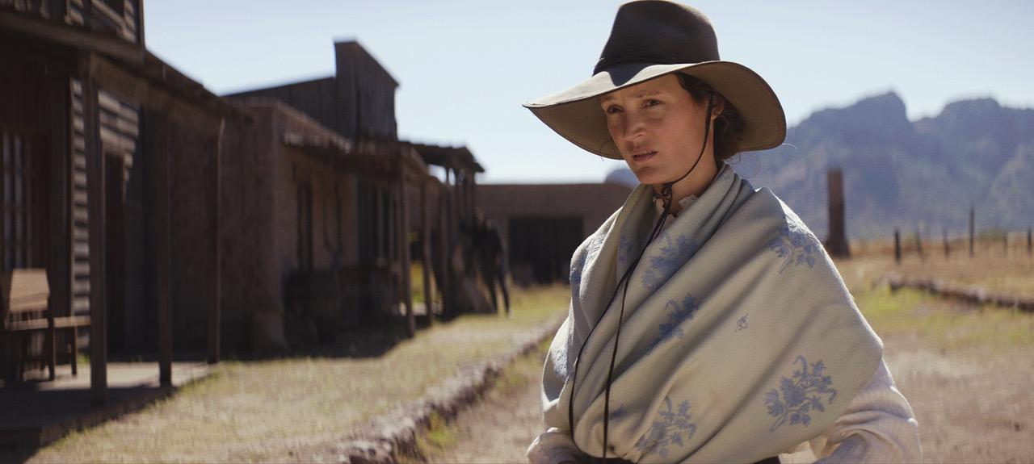

Says Mortensen: “She has a particular feminine beauty that seems to be from another time, and it’s perfect for our story—not just her outward appearance. She has something inside, a remarkable inner strength that she is able to transmit that is very well suited to this story.”

Krieps was excited to take on the role not only because she was intrigued by the idea of portraying Vivienne, but also because she was moved by the film’s striking relevance to modern life. “To me, Vivienne is a messenger,” Krieps says. “She carries a message from a time that is long gone. She lives in a world where people are fighting over land and are killing each other because some people think they should live everywhere, regardless of who else is there. Today, we are supposed to have moved on and to be evolved, but nothing has changed, really. The same people are oppressed, and the same people are the oppressors—and oppressors are still using sheer force to stay in power just because they’re stronger.

“In this chaos, Vivienne exists, and she’s lost, like everyone is lost, but something makes her strong,” Krieps continues. “It’s not that she’s physically strong. What she shows us is that she’s strong for a different reason, that she’s strong out of the act of forgiveness. Something that women have done, I think, over centuries, is to forgive men for their pride.”

Joining Krieps and Mortensen as part of the film’s ensemble is a gifted group of veterans and newcomers that includes Solly McLeod as Weston Jeffries. “Weston is kind of the brute, though there are other people influencing him, especially his father, and you start to realise that he’s more of a foot-soldier for the greater evil that’s going on in the town,” explains McLeod.

Mayor Rudolph Schiller, played by Danny Huston, exerts some of the greatest influence of all in Elk Flats—he perceives the community to be something like his fiefdom, and is willing to go to any lengths necessary to preserve his position of power. “It’s incredible to work within the *western* genre because you have strong archetypes, as in a Greek tragedy,” Huston says.

Working with the cast members as both director and scene partner, Mortensen found himself consistently impressed with the work unfolding on set. “You always want people to surprise you — the crew as well as the actors — and, as a director, I am very happy with what they have done. The actors in particular have arrived with surprises – daily gifts I would say - which have helped us to better tell this story.”

The actors had similarly kind words for Mortensen. “He’s a very attentive, loving, gentle spirit,” says Huston. “But he also has very clear intentions as to how he wants the scenes to play. So, it’s a combination of feeling free but also knowing what your parameters are.”

*The Dead Don’t Hurt* was filmed largely on location in Durango, Mexico, which had hosted many *western* productions - especially throughout the 1960s and ‘70s. A few scenes were also shot in Eastern and Western Canada. “We really liked the state of Durango, as it had the variety of landscapes we were trying to find for this movie—the high country, the forests, the deserts, the canyons,” Mortensen says. “We adapted the area to our specific purposes in some instances, of course, but the landscapes were generally ideal just as we found them.”

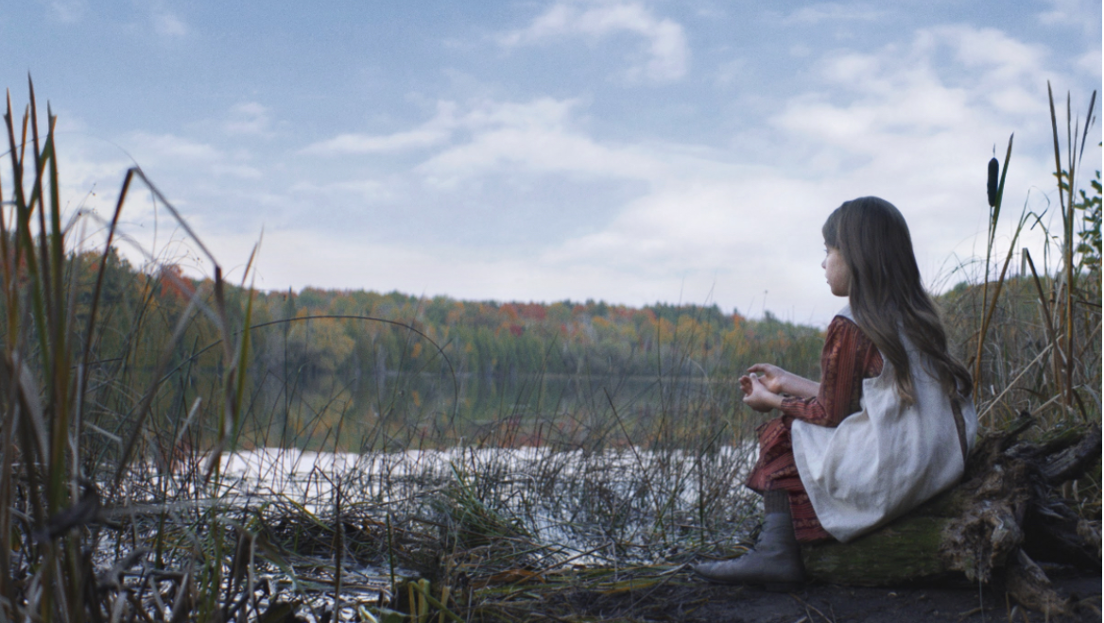

In developing the drama’s visual language with cinematographer Marcel Zyskind, production designers Jason Clarke and Carol Spier and costume designer Anne Dixon—all of whom had worked on *Falling*—Mortensen would share imagery from a wide-range of *western*s he’d seen over the years, sometimes honing in on the tiniest detail to help authentically create the feeling of life in Nevada during the period when the story unfolds. “When I watch *western*s, what I’m looking at, for one thing, is how do they ride?” Mortensen says. “How do they get on and off a horse? How do they hold the reins? Also, what is the vernacular, how do these people speak? All the period details, of course, and what do the landscapes look like that these people inhabit? So much to consider and explore.”

One of the story’s most pivotal environments is Olsen’s cabin, which is transformed once Vivienne comes to stay. Spier says the modest house was constructed in a canyon that was difficult to reach, but her goal was to create a structure that “would look like it had been there forever and would kind of melt into the rocky terrain,” she says.

“The place evolves through different stages of Vivienne’s life,” Spier says. “When she first arrives, Olsen had been living there alone for years, and it is a mess. She kind of takes over, and cleans it up. Inspired by Vivienne, he helps her plant the first trees and flowers. During his long absence, we see the place evolve as she adds to and nurtures the garden, completely transforming the place. The interior décor and the exterior of the home change significantly as she becomes increasingly self-sufficient while he is away fighting in the war.”

Zyskind sought to capture the majesty of the filming locations, which felt almost as though they existed out of time. “It’s bare bones,” Zyskind says of his approach. “It’s locations that just look different from your everyday life, which I think is great because that’s the magic of filmmaking. It’s like a time machine. You try to create a little pocket of a different time and tell a story within that. You have to embrace the sun there. The light in Durango, the near constant sunshine, the mountains, the locations, everything works as it should. It’s been such a joy.”

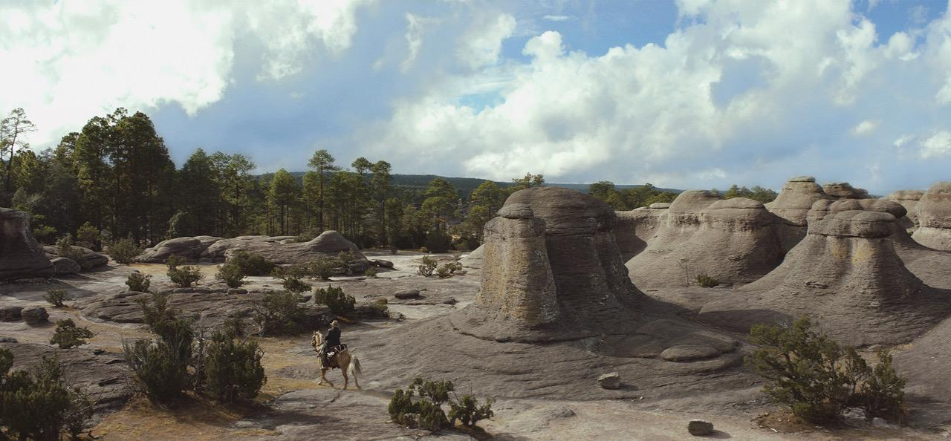

While preparing and shooting *The Dead Don’t Hurt*, Mortensen frequently felt quite moved by the extraordinary level of commitment that his collaborators displayed, helping him to realise his vision for the unique movie he sought to make.

“People gave a lot of themselves to tell this story, and when you have written something that comes from inside you and other people become interested—are willing to read it, to begin with, and then say *Yes, let’s see if we can do this together*—it is always surprising,” Mortensen says. “It’s very gratifying, I must say. So, more than anything I give thanks for the journey that they were willing to embark on with me, and that we were able to complete it beautifully and right on schedule. I think that all of us can feel good about that, proud.

“On the first day of the shoot, I said something that ended up on the call-sheet, which was, *I hope you will have a good time, but that the experience won’t punish you too much*”, he adds. “I pray that has been the case for everyone. I knew from the beginning that it would be hard, but I felt that we might enjoy ourselves as well, once in a while. Generally, I think that is how it turned out.”

**ABOUT THE CAST**

**VICKY KRIEPS (Vivienne Le Coudy)** had her international breakout role opposite Daniel Day Lewis in *Phantom Thread*, Paul Thomas Anderson’s masterpiece about the couturier Reynolds Woodcock set in 1950s London. The film received awards recognition and critics were struck by her performance.

Krieps earned similar acclaim for her role in *Corsage*, a fictional account of one year in the life of Empress Elisabeth of Austria directed by Marie Kreutzer. In 2022, Krieps won Best Performance in the Un Certain Regard category at Cannes Film Festival and Best Actress at both the European Film Awards and Sarajevo Film Festival. *Corsage* was long listed for the Best International Feature Film at the Oscars® and was nominated for a BAFTA Award for Best Film Not in the English Language.

Krieps starred as Hélène Mouchet opposite the late Gaspard Ulliel in Emily Atef’s *More Than Ever*, which premiered at the 2022 Cannes Film Festival. Hélène discovers she suffers from a rare lung disease and embarks on a journey across Europe to find peace and to meet a blogger she met online.

Earlier this year, Krieps starred in *The Three Musketeers: D’artagnan*, the first part of Martin

Bourboulon’s big budget, two-part feature, with Eva Green and Vincent Cassel. The second part, *The Three Musketeers*: *Milady*, is set to release in December. 2023 will also see Krieps star as Ingeborg Bachmann in Margarethe von Trotta’s *Ingeborg Bachmann: Journey into the Desert*, which premiered at Berlinale. The film follows the relationship between writers Bachmann and Max Frisch (Ronald Zehrfeld).

Krieps has just finished principal photography on *Hot Milk*, the much anticipated feature film based on the critically acclaimed novel by Deborah Levy. Directed by Rebecca Lenkiewicz, Krieps stars alongside Emma Mackey and Fiona Shaw. Further credits include Mia Hansen-Løve’s drama *Bergman Island* opposite Tim Roth; Mathieu Amalric’s *Moi Fort* (Hold Me Tight); Barry Levinson’s *The Survivor*; M. Night Shyamalan’s thriller *Old*; Netflix’s *Beckett*, opposite John David Washington; Govinda Van Maele’s *Gutland*; Raoul Peck’s *The Young Karl Marx*; Marie Kreutzer’s *We Used to Be Cool*; Fede Alvarez’s *The Girl in the Spider’s Web*, alongside Claire Foy and Sverrir Gudnason; TV mini-series *Das Boot*; *The Colony*, alongside Emma Watson and Daniel Bruhl; Anton Corbijn’s *A Most Wanted Man*; Roland Emmerich’s *Anonymous*; and Joe Wright’s *Hanna* starring Saoirse Ronan, Eric Bana and Cate Blanchett.

Having studied at the Zurich University of Arts, Krieps has featured in a variety of European film projects, and she was part of the ensemble at the Schauspielhaus Zurich for many years. Krieps made her screen debut in Eileen Byrne’s *La Nuit Passée* for which she was awarded Best Youngster in 2008 at the Busho Festival Budapest. She has also appeared in *Before the Winter Chill* directed by Philippe Claudel and starring Kristin Scott Thomas; Detlev Buck’s *Measuring the World*; and Georg Maas’s *Two Lives*. Other credits include *The Chambermaid*, *Brotherhood of Tears*, *Mobius* and *Tied*.

Krieps next stars in *The Dead Don’t Hurt* opposite Viggo Mortensen, which will premiere at the Toronto International Film Festival 2023.

**VIGGO MORTENSEN (Holger Olsen)** has earned acclaim for his acting work in a wide range of films. Some of these include *Thirteen Lives*, *Crimes of the Future*, *Green Book*, *Captain Fantastic*, *Eastern Promises*, *A History of Violence*, *The Road*, *Appaloosa*, *Far From Men*, *The Two Faces of* January, and *The Lord of the Rings* trilogy. He achieved notable praise for his directorial debut, *Falling*, which he also wrote and produced. He has received various nominations and awards from groups including; the Screen Actors Guild, the Academy of Motion Picture Arts and Sciences, the Hollywood Foreign Press Association, and the British Academy of Film and Television Arts. He is also a poet, photographer, painter, and is the editor and publisher of Perceval Press, an independent company he founded in 2002.

**SOLLY McLEOD (Weston Jeffries)** grew up in Orkney before moving to London at the age of 10. From April 2021 onward, McLeod filmed four projects back-to-back with only one day between each. He was in the Sky television series, *The Rising*, HBO’s *House of the Dragon*, the indie film *Jericho Ridge* and *Outlander.*

In 2023, McLeod will be seen as the eponymous hero in *Tom Jones* (ITV and PBS), starring alongside Hannah Waddingham and Sophie Wilde. He is also co-starring in *The Dead Don’t Hurt*, a western love story written and directed by Viggo Mortensen, opposite Vicky Krieps. He wrapped *Queer*, written and directed by Luca Guadagnino in Italy in June 2023.

Solly will begin shooting Nick Hamm’s film *Wilhelm Tell,* opposite Claes Bang, Rafe Spall and Ben Kingsley in September. He currently resides in London.

**DANNY HUSTON (Mayor Rudolph Schiller)** is an award-winning actor, writer and director known for his versatility and dramatic screen presence. Most recognised for his roles in films like Martin Scorsese's *The Aviator*, Alfonso Cuarón's *Children of Men* and Alejandro G. Iñárritu’s *21 Grams*, Huston has worked with some of the finest film directors of his generation.

Huston got his start directing *Mr. North* with Robert Mitchum, Anthony Edwards and his sister Anjelica Huston. He went on to give his breakthrough acting performance in the independent film *Ivans xtc* for which he was nominated for Best Male Performance at the 2003 Independent Spirit Awards. Since then his film acting work has included: *X-Men Origins: Wolverine*, Ridley Scott's *Robin Hood*, *Hitchcock* with Anthony Hopkins, *Wrath of the Titans* with Liam Neeson, *The Constant Gardener* with Rachel Weisz and Ralph Fiennes, Sofia Coppola's *Marie Antoinette*, John Sayles’s *Silver City*, *The Libertador* with Edgar Ramirez, *The Congress* with Harvey Keitel, John Hillcoat's *The Proposition* with Guy Pearce, *Birth* opposite Nicole Kidman, *30 Days of Night* with Josh Hartnett, Peter Berg’s *The Kingdom*, and many more.

In 2013, his critically acclaimed role of Ben the Butcher in *Magic City* (Starz!), earned him a Golden Globe nomination for Best Performance by an Actor in a Supporting Role in a Series, Mini-Series or Motion Picture Made for Television. His other television acting work includes the hit television series *Masters of Sex* (Showtime), a recurring role in the hugely popular *American Horror Story* (FX), and performances in *You Don’t Know Jack* with Al Pacino and John Adams (HBO/Playtone). Huston starred for two seasons as Dan Jenkins on the Taylor Sheridan and Paramount TV series *Yellowstone*: the number one series on television. Huston was also seen in the critically acclaimed series *Succession* for HBO.

In 2017, Huston portrayed Robert Evans in the stage adaptation of *The Kid Stays in the Picture* directed by Simon McBurney, for The Royal Court Theatre in London. Huston went on to appear in the global box office hit *Wonder Woman*, directed by Patty Jenkins.

Additional feature credits include *Paranoid* for Netflix and ITV Studios, Marc Forster's *All I See Is You*, *Frankenstein*, directed by Bernard Rose, *Pressure*, directed by Ron Scalpello; and Tim Burton’s *Big Eyes*. Huston also directed himself in *The Last Photograph*, which screened at the Edinburgh Film Festival and the Mill Valley Film Festival. Huston can be seen co-starring in *Angel Has Fallen* alongside Morgan Freeman and Gerard Butler, as well as the IM Global feature *Richard Says Goodbye* with Johnny Depp for writer/director Wayne Roberts. He also starred in the comedy feature *Game Night* with Jason Bateman and Rachel McAdams.

In 2021 and 2022, Huston filmed *Across the River and Into the Trees* with Liev Schreiber, *Tempête*, directed by Christian Duguay opposite Melanie Laurent, *Marlowe* opposite Liam Neeson and directed by Neil Jordan, *Consecration*opposite Jena Malone, the Italian film*Te l’avevo detto* *(I Told You So)*with Valeria Golino, and *The Crow*, directed by Rupert Sanders.

Most recently, Huston completed production on Kevin Costner’s *Horizon: An American Saga* and Viggo Mortensen’s second film as a director, *The Dead Don’t Hurt*, which will premiere at the Toronto Film Festival in 2023

**GARRET DILLAHUNT (Alfred Jeffries)** has several upcoming film projects, including his starring role opposite Orlando Bloom in the Nelms brothers’ actioner *Red Right Hand*, and as the land baron Alfred Jeffries in Viggo Mortensen’s *The Dead Don’t Hurt*.

Dillahunt segued from one zombie project going from AMC’s *Fear the Walking Dead*, as series regular John Dorie, to Zack Snyder’s Netflix movie, *Army of the Dead*, which was also released theatrically. He recently starred in and executive produces (along with Greg Garcia) the comedy series *Sprung*, for FreeVee/Sony. The series, about a high school weed dealer who gets out of prison early during the pandemic, reunites Dillahunt with *Raising Hope* co-star Martha Plimpton.

Dillahunt also appeared in the 2022 feature film *Where the Crawdads Sing*, based on the acclaimed novel, as well as co-starring in Michael Bay’s thriller *Ambulance*. He will recur in season three of the Starz acclaimed dramatic series *Hightown*, as Shane Frawley, a charismatic gangster from South Boston that tries to take over the Cape.

He previously starred in FOX’s half-hour comedy series *Raising Hope*. During the show’s four-season run, he stayed busy working continuously during his hiatuses on feature films such as *12 Years a Slave*, which won the Academy Award® for Best Picture, *Wheelman*, and the critically acclaimed *Winter’s Bone*, which earned him, and the rest of the cast, Best Ensemble at the Gotham Awards.

Other credits include *Any Day Now*, opposite Alan Cumming and directed by Travis Fine, which won Best Feature at 2012’s Out Film Festival, and the independent feature, *Amigo*, with Chris Cooper and directed by John Sayles. He also appeared in Rian Johnson’s *Looper*, the intriguing sci-fi action adventure with Emily Blunt, Joseph Gordon-Levitt, and Bruce Willis. Additionally, he received a Genie nomination for his portrayal of the title character, *Oliver Sherman*, in Ryan Redford’s directorial debut opposite Molly Parker and Donal Logue. He also worked alongside Viola Davis in Steve McQueen’s *Widows*.

His additional film credits include *The Road*, with Viggo Mortensen and Charlize Theron; Wes Craven’s *The Last House on the Left*; *The Assassination of Jesse James by the Coward Robert Ford*; and the Coen brothers’ Oscar®-winning drama *No Country for Old Men*, opposite Tommy Lee Jones. Dillahunt earned a SAG award for Best Ensemble for the latter.

The multi-faceted actor is probably best known for his work on the critically acclaimed HBO series *Deadwood*, in which he portrayed two entirely different characters: the assassin Jack McCall and the complex and deadly Francis Wolcott. After recognising his protean talent in his first incarnation, executive producer/writer David Milch created a second character for him.

Additional television credits include the recent Showtime historical drama *Ghosts of Beirut*, *Dead to Me*, *Terminator: The Sarah Connor Chronicles*, *John from Cincinnati*, *ER*, *The 4400*, *Damages*, *Life*, *Lie to Me*, *Law & Order: Special Victims Unit*, *Criminal Minds*, *Burn Notice*, *White Collar*, *Alphas*, and *Memphis Beat*.

He boasts an outstanding theatrical resume and has performed extensively on and off Broadway and at such respected theatre companies as Steppenwolf, ACT San Francisco, the Seattle Repertory Theatre, Huntington Theatre Company, Williamstown Theatre Festival and the Berkshire Theatre Festival. Dillahunt resides in Los Angeles and New York.

**COLIN MORGAN (Lewis Cartwright)** is an incredibly diverse actor working across stage and screen. He was most recently seen in Amazon’s *Mammals*, a British dark comedy written by Jez Butterworth and directed by Stephanie Laing. His other notable television credits include *Humans*, *The Crown* and *The Fall*. His recent feature work includes Jonathan Kent’s *Long Day’s Journey into Night*, alongside Ed Harris, Jessica Lange and Ben Foster; *Dead Shot*, for Sky;

Kenneth Branagh’s Academy Award®-winning film *Belfast*; and the German feature *Corsage* alongside Vicky Krieps, which won numerous awards at international film festivals.

Morgan also has starred in stage in productions including the critically acclaimed *Translations* at The National Theatre, directed by Ian Rickson; *All My Sons* at the Old Vic; and *Mojo* at the Harold Pinter Theatre. He also features in Viggo Mortensen’s *The Dead Don’t Hurt*, with Vicky Krieps, premiering at this year’s Toronto International Film Festival.

**RAY McKINNON (Judge J. Blagden)** is an actor, writer, director and producer, most well-known for creating the critically acclaimed series *Rectify*, one of the best-reviewed shows of all time, per the Guinness Book of World Records. The show received a Peabody Award, while also landing two Critics Choice TV Award nominations.

As an actor, McKinnon has created a canon of unforgettable, offbeat and richly textured characters. In a career spanning two decades, McKinnon has steadily built an impressive resume. He will soon be seen playing an assassin in two of the films in the John Wick prequel series *The Continental*, for Lionsgate and director Albert Hughes, as well as the film *The Dead Don’t Hurt*for director Viggo Mortensen, and Michael Keaton’s directorial debut *Knox Goes Away*. Both films will be at TIFF 2023.

Other big screen credits include the Universal film *News of the World* for director Paul Greengrass, opposite Tom Hanks and FOX’s award-winning film from director James Mangold, *Ford vs Ferrari* starring opposite Matt Damon and Christian Bale. Other memorable film credits include Jeff Nichols’ *Mud* and *Take Shelter*; the Coen brothers’ *O Brother, Where Art Thou?*; John Lee Hancock’s *The Blind Side*; Derek Martini’s *Hick*; Craig Brewer’s *Footloose*; Ron Howard’s *Apollo 13*; and Barry Levinson’s *Bugsy*.

His memorable TV roles include FX’s critically acclaimed *Sons of Anarchy* (as Lincoln Potter) and the current FX series *Mayans*, again as Lincoln Potter. He was recently seen in the limited series *Dopesick* for Fox/Disney and creator Danny Strong. Other credits include the award-winning HBO series *Deadwood* as Reverend H.W. Smith. He also has appeared in such series as *Comanche Moon*, *The X Files*, *Justified* and *Matlock* among many others.

As a filmmaker, he produced and starred in the critically praised indie feature *That Evening Sun* and garnered an Independent Spirit Award nomination for Best Supporting Actor for his work as Lonzo Choat, opposite Hal Holbrook.

Truly embracing all creative aspects of film, McKinnon has complemented his acting credits with other notable turns as a writer, director and producer. Collaborating with Walton Goggins frequently under the Ginny Mule Pictures banner, together they debuted McKinnon’s *The Accountant*, which won an Academy Award for Best Live Action Short in 2002. Their first feature film *Chrystal*, directed and written by McKinnon, was selected for the Sundance Film Festival’s prestigious Dramatic Film Competition in 2004.

**W. EARL BROWN (Alan Kendall)** was born in Golden Pond, Kentucky. The seeds of his career as an actor and writer were sewn there as he spent his childhood years entertaining all who gathered on his grandparents’ front porch. Brown received his MFA from DePaul University’s Theatre School in 1989. After graduation, he performed in numerous plays around Chicago, but it was his performance in *A View from the Bridge* at the Steppenwolf Theatre that catapulted his career into television and film. Wes Craven was an early supporter, casting him in the box-office smash, *Scream*. Two years later, Brown played the breakout role of Warren, Cameron Diaz’s mentally challenged brother, in *There’s Something About Mary*.

Brown can be seen in the upcoming independent film *The Dead Don’t Hurt* starring Viggo Mortensen, and in recurring roles such as HBO’s *Hacks* and Disney+/LucasFilm’s *The Mandalorian*/The Book of Boba Fett. His other releases are Apple+ drama Five Days at Memorial, Apple+ comedy *Hello, Tomorrow!*, Season two of Paramount+ *The Mayor of Kingstown*, and he plays George Wallace in John Ridley/Regina King’s *Shirley*.

In addition to his television and film work, Earl also writes music and records with Sacred Cowboys, an L.A.-based Americana band.

**ATLAS GREEN (Little Vincent**) is an intrepid young performer from Ontario who enjoys music, riding horses, swimming, kayaking, mountain biking, gardening, and taking care of animals. He is fluent in English and French, and when he grows up, he dreams of continuing his work in film, becoming a farmer or a Lego master builder. *The Dead Don’t Hurt* marks his feature debut.

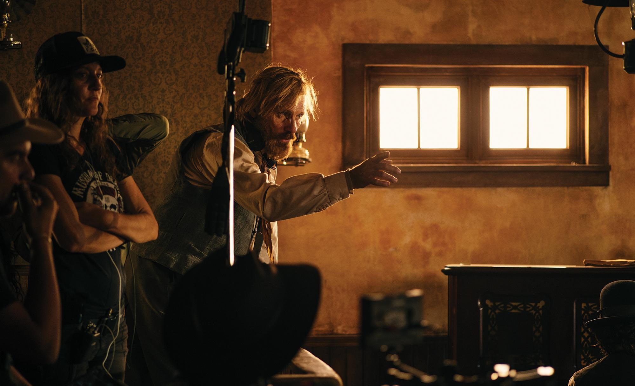

**ABOUT THE FILMMAKERS**

**VIGGO MORTENSEN (Writer, director, composer, producer)** received critical acclaim for his directorial debut, *Falling*, which he also wrote and produced. Additionally, he was a producer on Lisandro Alonso’s *Jauja*, David Oelhoffen’s *Loin des hommes*, Ana Piterbarg’s *Todos tenemos un plan*, and Henry Mortensen’s *Ugly Pop*.

**REGINA SOLÓRZANO (Producer)** graduated from the Film and Television program at Centro University in Mexico City. In 2011, she joined Viacom’s creative team as the creative coordinator for internal content, and later assumed the role of sales manager. In 2013, she joined the film and television production and distribution company CANANA as director of public relations and strategic alliances for project production. Subsequently, in 2014, she joined the production company Fábrica de Cine, where she oversaw and led the writers' table and Cinematographic Project Development department.

From January 2018 to the present day, Solórzano has served as the CEO of Talipot Studio, a hub for content creation, production and development for film and television. During this time, she has been involved in the consolidation of acclaimed international projects including *Annette*, *Bergman Island*, *Triangle of Sadness*, *Kings of the World* and *Eureka*, and has led two original productions: *Tú eres mi problema*, directed by Álvaro Curiel and released on Amazon Prime Video; and *The Dead Don’t Hurt*, directed by and starring Viggo Mortensen, set to premiere at the 2023 Toronto International Film Festival.

**JEREMY THOMAS (Producer)** began his film career working in the cutting rooms and soon became an editor. In 1974, Thomas produced his first film, Philippe Mora’s *Mad Dog Morgan* starring Dennis Hopper, and then founded Recorded Picture Company. Thomas went on to produce many distinctive films, such as Jerzy Skolimowski’s *The Shout*, Nicolas Roeg’s *Bad Timing*,*Eureka* and *Insignificance*, and Nagisa Ôshima’s *Merry Christmas Mr. Lawrence*.

In 1986, Thomas collaborated with director Bernardo Bertolucci on *The Last Emperor*, which won nine Academy Awards® including Best Picture, and many other international awards. Thomas went on to make *Little Buddha,The Sheltering Sky*, *Stealing Beauty* and *The Dreamers* with Bertolucci in a partnership spanning over 30 years.

Thomas has chosen to remain an independent producer, resulting in a diverse body of work, including such titles as David Cronenberg’s *Naked Lunch*, *Crash* and *A Dangerous Method,*Takeshi Kitano’s *Brother,* Jonathan Glazer’s *Sexy Beast*, David Mackenzie’s *Young Adam*, Takashi Miike’s*13 Assassins*, *Hara-Kiri*: *Death of a Samurai,* *Blade of the Immortal*and*First Love,*the Oscar®-nominated *Kon-Tiki* by Joachim Roenning and Espen Sandberg, Jim Jarmusch’s *Only Lovers Left Alive*, Ben Wheatley’s *High-Rise*, *Tale of Tales, Pinocchio* and *Dogman* by Matteo Garrone, and *EO*byJerzySkolimowski*.*

Throughout his career, Thomas has worked with many other leading filmmakers including Stephen Frears, Richard Linklater, Phillip Noyce, Wim Wenders, Terry Gilliam and Bob Rafaelson. In 1992, Thomas was appointed Chairman of the British Film Institute and was made a Life Fellow in 2000. He has been President of the Jury at the Tokyo, San Sebastian, Berlin and Cannes film festivals (Un Certain Regard) and has also served on the main Jury at Cannes.

Thomas has produced more than 70 films, 20 of which have premiered at Cannes in Official Selection.

**MARCEL ZYSKIND (Director of Photography)** lives in Denmark and works internationally on an array of films, television projects, documentaries and commercials. His many films include *Dalíland*directed by Mary Harron, *As in Heaven*, directed by Tea Lindeburg, *The Dead Don’t Hurt* and *Falling*, directed by Viggo Mortensen, *The Day Shall Come*, directed by Chris Morris, *Steel Country*, directed by Simon Fellows,*Two Faces of January,*directed by Hossein Amini, *Summer 92,* directed by Kasper Barfoed, *Skyscraper*, directed by Rune Schjøtt, *Bullet Boy* for director Saul Dibb, *Mammoth* for director Lukas Moodysson and *Mister Lonely* for director Harmony Korine.

He is well known for his frequent collaborations with director Michael Winterbottom, which include *Everyday, Trishna*, *The Killer Inside Me*, *Genova*, A *Mighty Heart*, *The Road to Guantanamo*, *Tristram Shandy: A Cock and Bull Story*, *9 Songs*, *Code 46*, and *In this World*. Among his music videos is Massive Attack’s*Live with Me* for director Jonathan Glazer.

**CAROL SPIER (Production designer)** is an award-winning international production designer, based in Toronto, Canada. She is known for her long collaboration on 15 films with director David Cronenberg, including *Eastern Promises*, for which she earned a Genie Award nomination; *Dead Ringers*, for which she won the Genie Award for Best Production Design; *A History of Violence*; *Maps to the Stars*, for which she won DGC Craft Award; and *Crimes of the Future*.

Spier has also worked with director Guillermo del Toro on several films including *Pacific Rim*, *Blade 2* and *Mimic*. Other notable credits include Paul Gross’ *Passchendale*, for which she won Genie and DGC Outstanding Achievement Awards. Other credits include *The League of Extraordinary Gentlemen* for director Steve Norrington, Christopher Gans’ *Silent Hill* and Jim Sheridan’s *Dream House*. Spier received the DGC Lifetime Achievement Award in 2009.

Spier’s recent credits include director Jodie Foster’s *Black Mirror* episode “Ark Angel”; the television series *11/22/63*, directed by Kevin MacDonald; Lone Sherfig’s *The Kindness of Strangers*; *Falling*, directed by Viggo Mortensen; and *The Shrouds*, directed by Cronenberg.

**JASON CLARKE (Production designer)** is a multiple award-winning production designer and art director based in Toronto, Canada. With a career spanning more than 20 years, Clarke has run the gamut from low-budget indie productions to multimillion dollar studio features, acquiring a phenomenal skillset and creating collaborative experiences to make intelligent, strategic and creative decisions that he brings to each project.

Clark’s production design credits include Clement Virgo’s multi award- winning feature *Brother*, for which Clark won the Canadian Screen Award for Best Production Design; Mark O’Brien’s feature film directorial debut, *The Righteous*, for which Clarke earned a Directors Guild of Canada nomination for Production Design.

His additional credits include director Jodie Foster’s Black Mirror episode “Ark Angel,” along with Neil Jordan’s *Greta*, Lone Scherfig’s *The Kindness of Strangers*, and actor Viggo Mortensen’s feature film directorial debut, *Falling*. In addition to *The Dead Don’t Hurt*, Clark recently completed serving as art director for *The Shrouds*, the latest feature from acclaimed director David Cronenberg.

**PEDER PEDERSEN (Editor)** is a versatile filmmaker known for directing the (in)famous Aqua “Barbie Girl” music video and crafting visuals for The Raveonettes. He has directed more than 1,500 commercials and helped create animated TV shows including *Chima* and *LEGO City*. Notably, Pedersen shared a close collaboration with Viggo Mortensen during the post-production of Mortensen's debut feature film *Falling*. Pedersen is currently in post-production on his first feature as a director.

**ANNE DIXON (Costume Designer)**is a costume designer whose work has been seen internationally both on stage and onscreen for more than two decades. Her collaboration with such directors as David Cronenberg, Viggo Mortensen, François Girard, Niki Caro, Jeremy Podeswa, Mick Jackson, Angelica Huston, Paul Mazursky, Kathy Bates, Bob Gale, Sudz Sutherland and Veronica Tennant have kept her designs fresh and inspiring. Her feature films include *The Shrouds, The Marsh King’s Daughter, Falling, The Song of Names*, *Lavender*, *Born to Be Blue*, *Fugitive Pieces*, *Saint Ralph*, and *Interstate 60*, to name but a few.

Dixon is a graduate in Art & Design from The University of the Arts, London, England.

